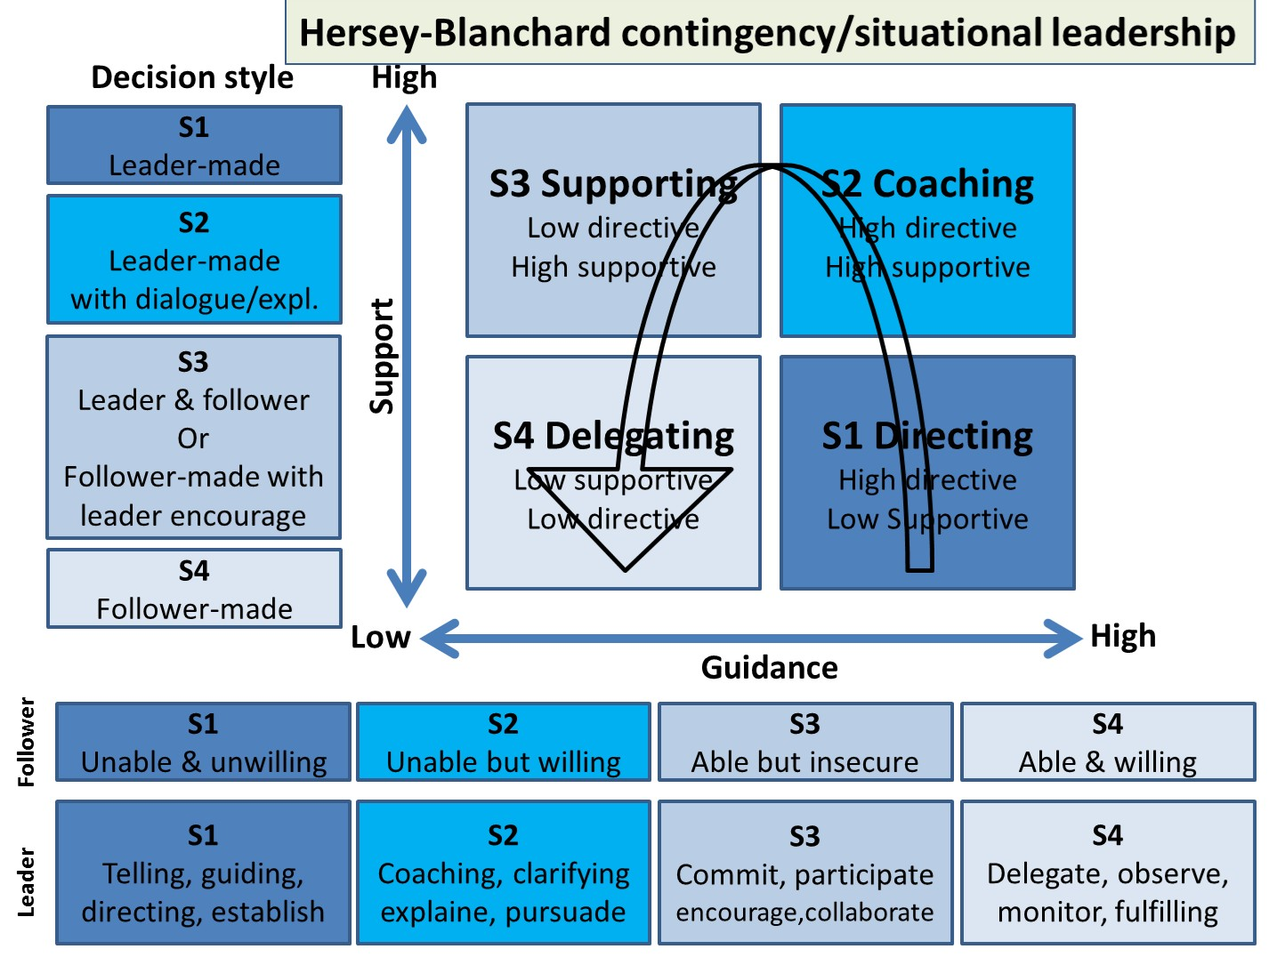
http://leadingthoughtfully.com/finding-the-balance-between-being-task-and-people-oriented/

